# TO-DO LIST

### A MINI PROJECT REPORT

#### Submitted by

#### Group-8/Team No: PG-2

**HARSHITA**

**Rollno:2310990601.**

**Submitted to: Ms. Rajwinder Kaur**

#### in partial fulfillment for the award of

#### the degree of

## BACHELEOR OF ENGINEERING

***in***

COMPUTER SCIENCE & ENGINEERING



**CHITKARA UNIVERSITY**

**CHANDIGARH-PATIALA NATIONAL HIGHWAY**

**RAJPURA (PATIALA) PUNJAB-140401 (INDIA)**

# OCTOBER 2023-24

**ABSTRACT**

A to do list is a list of tasks that need to be completed, typically organized in order of priority. It is one of the simplest solutions for task management and provides a minimal and elegant way for managing tasks a person wishes to accomplish.

Our aim is to design a simple and elegant website for people to keep track of the status of their tasks. Making a to-do list is an easy and important task that everyone should do. The immense satisfaction that one gets when completing the task and marking it on the list is incomparable. Moreover, creating a list of tasks ensures you don’t miss out on anything. It’s a scientific fact that when you write the tasks that you need to complete, you are even more motivated to complete them. With this in mind, we come to build a platform which will help people to create their own task list.

With the help of modern tools and technologies, we strive to build a minimal and efficient to-do list which minimizes distractions and helps people achieve task management with case and without hassle.

**TABLE OF CONTENT**

|  |  |  |
| --- | --- | --- |
| **S.NO.** | **SECTION** | **PAGE.NO** |
| 1 | Introduction | 1 |
| 2 | Problem Statement | 2 |
| 3 | Technical Details | 3 |
| 4 | Key Features | 4-5 |
| 5 | Advantages of To-Do list | 6-7 |
| 6 | HTML and CSS Code | 8-10 |
| 7 | Conclusion | 11 |
| 8 | Future Scope | 12 |
| 9 | References | 13 |

**1.INTRODUCTION**

A to-do list is a simple web page element that allows users to input and manage a list of exercises for practicing HTML and CSS skills. A to-do list created using only HTML, CSS. This approach results in a lightweight and fast-loading web page element that can be easily styled to match any website or application design.

With the help of To-Do List, we can add a list of tasks that we need to get done in the future. Traditionally, they were written on paper or slog. Today, however, people are using technology to quickly note down their important tasks to set reminders for the upcoming time.

By prioritizing the task in the list, you plan the order in which you are going to do then and quickly see what needs your immediate attention and what task you can leave until a little later. It helps you to stay organized. It helps to keep you motivated, as you see yourself being productive through the list.

The scope of the To-Do List Project extends across various domains of life and work. It is designed to cater to a broad audience, including students, professionals, entrepreneurs, and homemakers. This project is not limited by boundaries; it can be customized to suit your unique needs and requirements, offering flexibility and adaptability to different contexts.

Whether you're embarking on a complex project, aiming to meet personal goals, or simply seeking a more efficient way to manage your daily to-dos, the To-Do List Project provides a comprehensive solution. It empowers you to categorize tasks, set priorities, assign deadlines, and collaborate seamlessly with others, all while reducing the mental burden associated with task management.

**2.PROBLEM STATEMENT**

In today's increasingly fast-paced and demanding world, individuals and teams face a multitude of tasks, commitments, and responsibilities. The inability to effectively manage these tasks often leads to stress, missed deadlines, reduced productivity, and a sense of overwhelm. People struggle with:

**2.1 Information Overload:**

With the constant influx of information, it's easy to lose track of critical tasks and deadlines, causing unnecessary stress and anxiety.

**2.2 Disorganized Workflows:**

Many individuals lack a structured approach to task management, resulting in scattered to-do lists, misplaced priorities, and inefficient work processes.

**2.3 Team Collaboration Challenges:**

Collaboration within teams can be hindered when tasks are not clearly defined, assigned, and tracked, leading to miscommunication and decreased productivity.

**2.4 Ineffective Time Management:**

Without clear task prioritization and scheduling, individuals often find themselves working on less important tasks while neglecting crucial ones.

**2.5 Accountability Issues:**

The absence of a reliable system for tracking task progress can make it difficult to hold individuals and teams accountable for their responsibilities.

**3.TECHNICAL DETAILS**

**3.1 HTML:**

HTML provides a structured way to organize content on the web. It allows us to define the different elements of a webpage, such as headings, paragraphs, lists, images, tables, and more. By using HTML tags, we can create a logical structure for our content, making it easier for both humans and search engines to understand.

**3.2 CSS:**

CSS (Cascading Style Sheets) is a crucial component of web development that is used for styling and visually enhancing web pages. CSS provides a consistent way to apply styles to multiple elements across a website. By defining styles in a central CSS file, we can easily apply the same visual properties (such as colors, fonts, margins, and padding) to multiple elements.

**3.3 JAVASCRIPT:**

JavaScript is a fundamental component in the development of a to-do list application, contributing significantly to its dynamic and interactive nature. As a client-side scripting language, JavaScript enables real-time updates and responsiveness within the app's user interface. Through the manipulation of the Document Object Model (DOM), JavaScript facilitates the seamless addition, modification, and removal of tasks, providing users with a smooth and intuitive experience without the need for page reloads.

Furthermore, JavaScript plays a crucial role in managing the persistence of tasks. By utilizing local storage or communicating with a backend server, JavaScript ensures that users' task data is stored securely and can be retrieved consistently, even across different sessions.

**4.KEY FEATURES**

**4.1 Task Categories:**

4.1.1 Subcategories: Organize tasks into fine-grained categories for precise management.

4.1.2 Customization: Adapt categories to your specific needs, allowing for tailored task organization.

**4.2 Priority Levels:**

4.2.1 Priority Definitions: Clearly define the significance and impact of each priority level (High, Medium, Low).

4.2.2 Color Coding: Visual cues through color-coding for quick identification of task priorities.

**4.3 Due Dates:**

4.3.1 Setting Reminders: Easily set reminders and due dates to stay on top of time-sensitive tasks.

4.3.2 Recurring Tasks: Automate repetitive tasks by scheduling them to recur at specified intervals.

**4.4 Status Tracking:**

4.4.1 Status Definitions: Detail the meanings behind status labels (Not Started, In Progress, Completed).

4.4.2 Progress Visualization: Graphical representation of task progress, providing at-a-glance insights.

**4.5 Notes and Comments:**

4.5.1 Collaboration Notes: Add comments and notes to tasks for improved collaboration with team members.

4.5.2 Documentation: Attach relevant documents, images, or links to tasks for comprehensive information storage

**4.6 Progress Tracking:**

4.6.1 Milestone Definition: Clarify what constitutes a milestone, enabling precise tracking of project progress.

4.6.2 Historical Data: Maintain historical records of task completions and milestones achieved.

**4.7 Collaboration:**

4.7.1 Task Assignment: Assign tasks to team members with clear responsibilities and deadlines.

4.7.2 Real-time Updates: Receive real-time updates on task progress, ensuring seamless collaboration.

With these comprehensive features, the To-Do List Project empowers users to manage tasks effectively, adapt to changing priorities, and collaborate effortlessly, ultimately leading to a more organized and productive life or work environment.

**5.ADVANTAGES OF TO DO LIST**

**5.1 Enhanced Productivity:**

By streamlining tasks and providing clear priorities, the To-Do List Project helps individuals and teams boost overall productivity.

**5.2 Effective Organization:**

Precise task categorization and prioritization significantly enhance work efficiency and time management.

**5.3 Meeting Deadlines:**

Setting due dates ensures timely task completion, reducing the risk of missed deadlines.

**5.4 Team Collaboration:**

Seamless collaboration tools facilitate teamwork, resulting in enhanced project outcomes.

**5.5 Time Management:**

Allocating time wisely to high-priority tasks maximizes productivity and minimizes wasted effort.

**5.6 Stress Reduction:**

By preventing the oversight of important tasks, the project reduces mental clutter and minimizes stress.

**5.7 Accountability:**

Task progress tracking promotes accountability among individuals and teams, ensuring that responsibilities are met.

**5.8 Improves Your Memory:**

A to do list acts as an external memory aid. It’s only possible to hold a few pieces of information at one time. Keep a to-do list and you’ll be able to keep track of everything, rather than just a few of the tasks you need to do. Your to do list will also reinforce the information, which makes it less likely you’re going something

**6.HTML AND CSS CODE**

**6.1 HTML CODE:**

To explain briefly; in the <head> section we add <style> and a favicon tag. Then it comes to <body>, we have 2 tags <h1>and <div> and below we have a text input element for the user to enter the To Do items in, and a button that we will use for getting the input values. This is where we will display the input items in list, when we get inputs from the user.

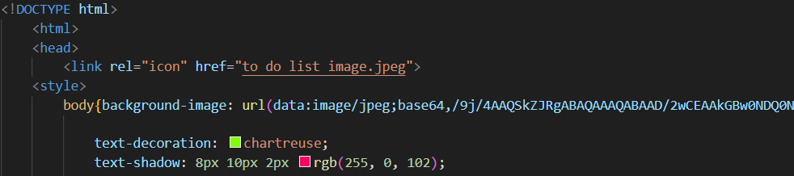

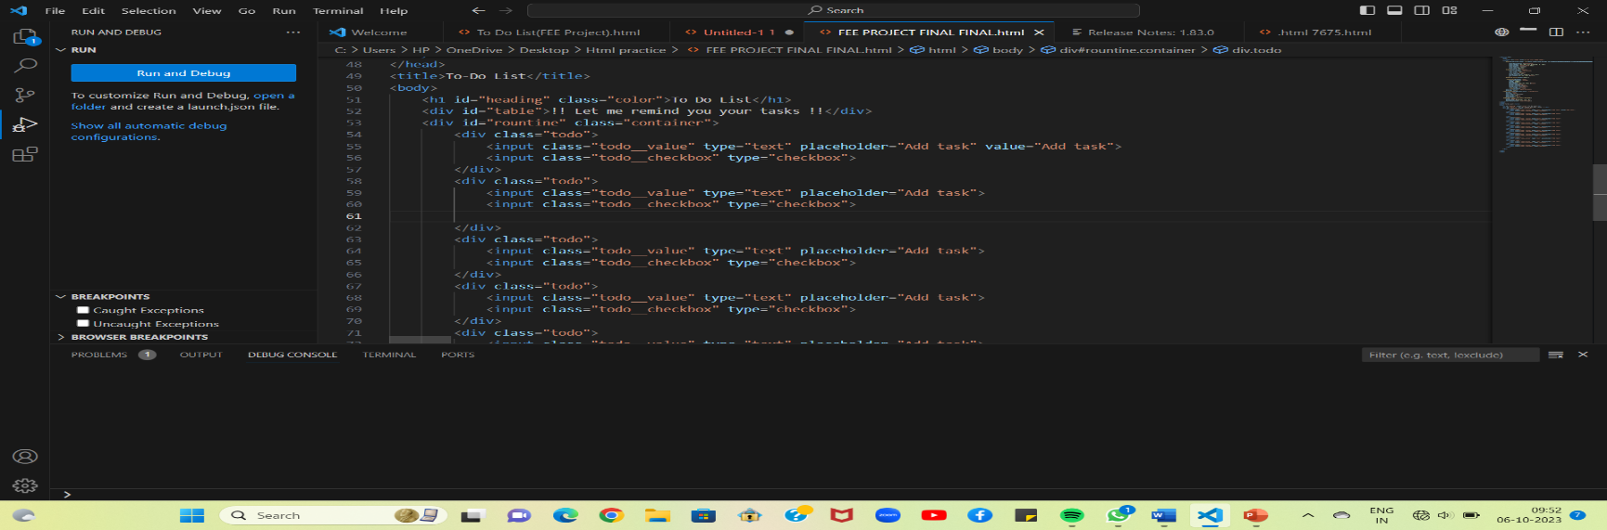

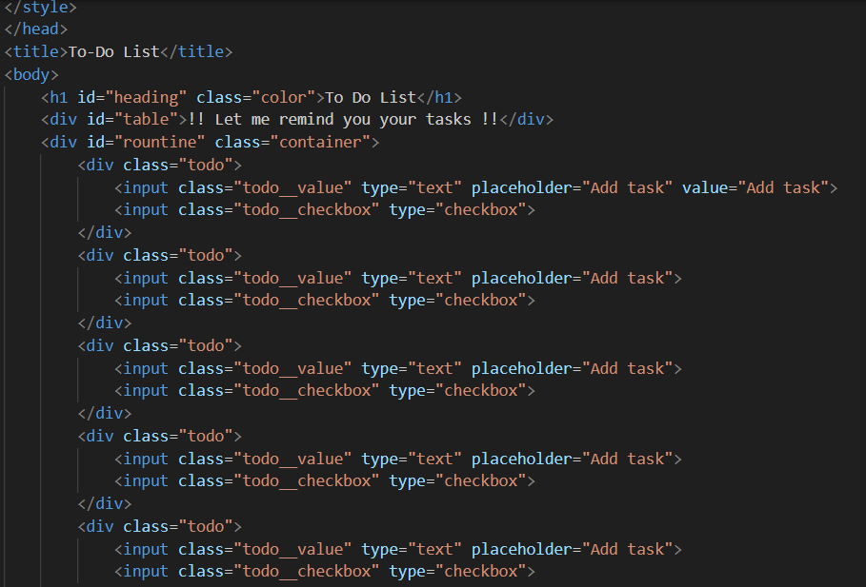

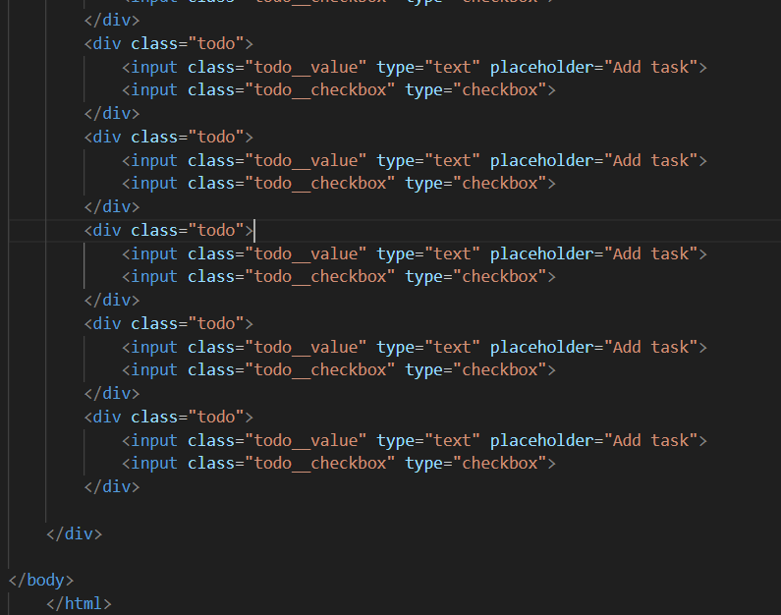

**6.2 CSS CODE:**

Here it comes are style tag, so here we have done styling of our project. we have applied a hover tag , flex and used line through.

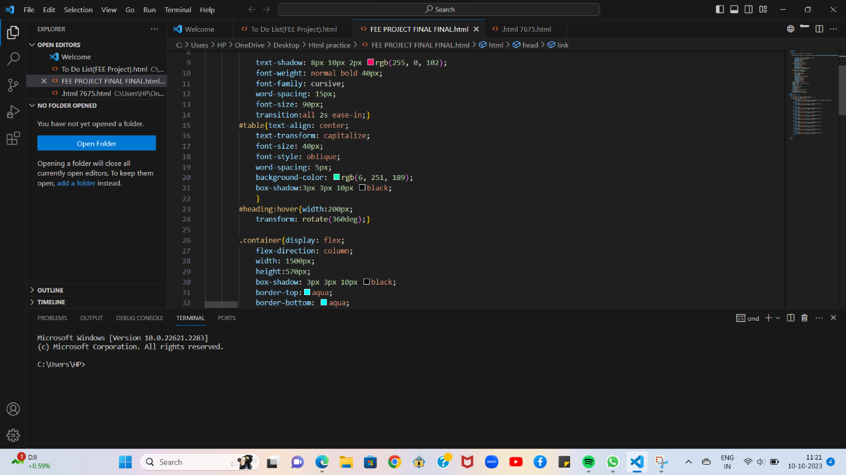

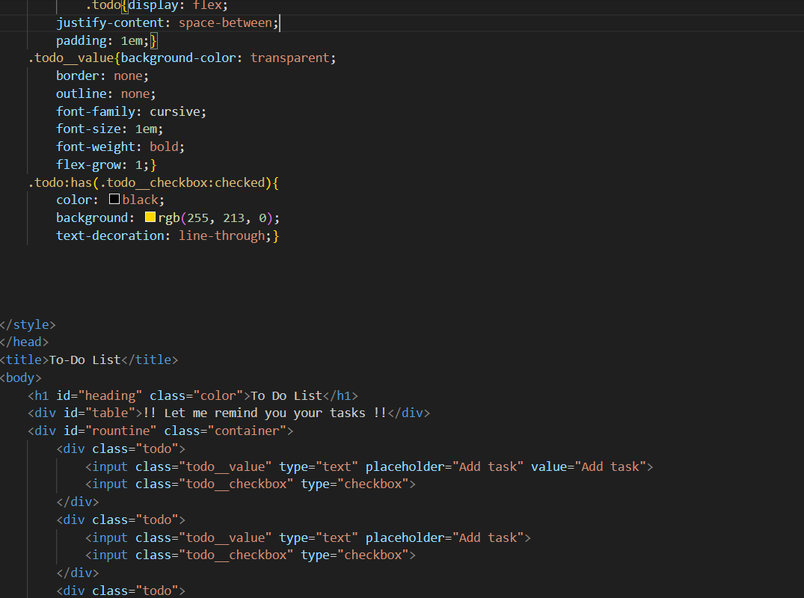

**7.CONCLUSION**

In conclusion, the To-Do List Project represents a holistic approach to task management, encompassing a wide range of features and benefits. By implementing this project, users can regain control over their tasks, reduce stress, and improve overall productivity. The journey doesn't end here; the project's future holds exciting possibilities for integration, customization, and continued growth, ensuring its relevance and utility in the ever-evolving landscape of task management.

**8.FUTURE SCOPE**

**8.1 Integration with Calendar Apps:**

Discuss potential integration with popular calendar apps, enabling seamless synchronization of tasks and events.

**8.2 Mobile App Development:**

Explore the development of a dedicated mobile app, empowering users to manage tasks on-the-go.

**8.3 Advanced Analytics:**

Consider adding advanced analytics and reporting tools, providing valuable insights into task management and productivity.

**8.4 Integration with Project Management Tools:**

Investigate possibilities for integration with popular project management tools, facilitating large-scale project tracking and coordination.

**9.REFERENCES**

**The following references were used in the development of this project To-Do list:**

**. Tech Vidvan:** [**https://techvidvan.com/tutorials/python-to**](https://techvidvan.com/tutorials/python-to)

**. Project Manager:** [**www.projectmanager.com/template**](http://www.projectmanager.com/template)

**. Gate Hub:** [**https://gatehub.net**](https://gatehub.net)